Integrated Order Navigation System

(I.O.N.S)

User Guide and Documentation

By: Silne Dorlus

Date: 07/23/2012

Contents

Overview 4

Description 4

Rationale 4

Project Schedule 5

Requirements to run I.O.N.S 6

Software and Hardware 6

Responsibilities 7

Data Frequency, Volume, Size 8

Application and System Documentation 8

Entity Relationship Diagram 8

Table Schema 9

PRODUCT 9

EMPLOYEE 9

CLIENT 9

INVOICE 10

INVOICEDPRODUCT 11

CLIENTSPRODUCT 11

ORDERS 11

ORDEREDPRODUCT 12

Program Data Flow Diagram 13

Report Data Flow Diagram 14

Database Schema 15

Data Controls 20

Data Backup 20

Database Constraints 20

Form Verification 22

I.O.N.S User Documentation 30

Data Conversion 30

Operating I.O.N.S 30

Logging into I.O.N.S 30

Inside of I.O.N.S 32

Section 1: Client Search (Shown above) 32

Section 2: New Client Order Entry(Administrators and Salespeople) 37

Section 3: Order Search 43

Section 4: Invoices (All Roles) 50

Section 5: Reports (Report availability based on role) 52

Section 6: Help and Support (All Roles) 55

# Overview

### Description

Integrated Order Navigation System (I.O.N.S) is a web based order entry system for the management of clients, their products, invoices, etc.

### Rationale

1. **Better Performance and Service** – This project will increase the efficiency of customer service associates. As it stands, the customer service representatives have to contact other departments to get access to information that is integral to their daily activities. This system will give the service representatives a single point for all of their informational needs at their fingertips. Also, having a web based solution will allow for future expansion of web based service to the customer such as online billing and management, online orders and product lookup.
2. **More Information** – Having an information system allows for product management and planning, sales trending, forecasting, product penetration analysis, and other analytics just from a few clicks where it is virtually impossible to do it with the current system.
3. **Stronger Controls** – The current system uses a batch to send unencrypted files containing sensitive customer information to other departments via standard email. This is a huge security risk. It wouldn’t take much for the data to be compromised. The proposed system gives a centralized location for information; create users with roles and permissions, and opportunities for disaster recovery and backup. There was an incident that almost resulted in a lawsuit due to compromised information and we don’t want to run the risk of a repeat. Since all of the data would be in one place, there would be much less risk of duplicate information and all affected parties would have access to the same information.
4. **Reduce Cost** – With the recent increase in volume, it would cost the company more to add more employees and create more room for error. Continuing to conduct business with the current system may also prove to be a costly venture if there is ever a lawsuit for information that was compromised. Data can be compromised with any system but the proposed solution would be much more secure and it would be much less likely to happen.

### Project Schedule

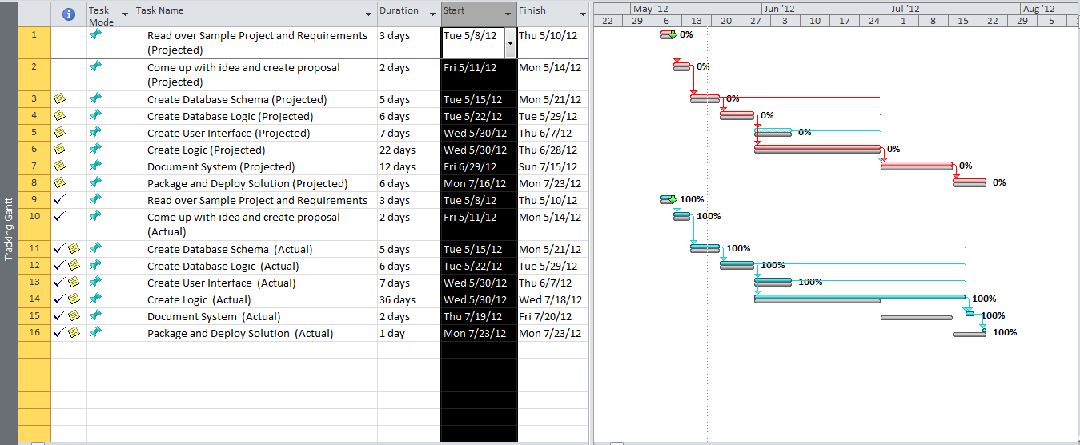

# Requirements to run I.O.N.S

### Software and Hardware

I.O.N.S is a web application that can be hosted from the web or ran from the local host on a windows enabled computer. For the work environment at Plumbob Communications, LLC the choice was to have the application ran from the local machines.

I.O.N.S was developed as windows based web application targeting the .NET Framework version 4.0. The minimum software requirements for the .NET Framework are as follows:

**Processor**: 1GHZ

**RAM:** 512 MB

**Disk Space:** 32 Bit - 850MB; 64 Bit – 2 GB

**Operating System:** Windows XP Home Edition and up.

I.O.N.S is cross browser compliant but there are some bugs that are evident in certain browsers. I.O.N.S is optimized and working 100% in Google Chrome and Apple Safari. In Opera, there is one report (Pending Orders) that does not properly display. In Microsoft Internet Explorer and Mozilla Firefox, there are 2 reports that do not display properly (Sales report and referrals report). For the best experience, it is best to use Google Chrome or Apple Safari. ***JavaScript must be enabled for I.O.N.S to function!*** The minimum browser versions are as follows. Please try to use as current a browser as possible to reduce chance of bugs:

* Internet Explorer 7+
* Mozilla Firefox 3+
* Google Chrome (All Versions)
* Opera 9.5+
* Safari (All Versions)

The minimum hardware requirements for the .NET Framework 4.0 would be more than sufficient to run all of the browsers listed at any version.

I.O.N.S is built to run from the local host as its web server. For the .NET Environment, that is Internet Information Services (IIS). The minimum version for IIS is 5.1. (There are compatibility settings to set up if you have higher than 6.0. See configuration section.)

I.O.N.S is designed to use a database built in SQL Server 2008 Express. An instance of SQL Server 2008 is needed to be able to access the database. The minimum requirements for SQL Server 2008 Express are as follows:

**Processor**: 32 Bit – 1.0GHZ; 64 Bit – 1.4 GHZ (2.0 GHZ or faster recommended for either)

**RAM:** 256MB (1GB or more recommended)

**Disk Space:** 1 GB

**Operating System:** Windows XP SP1 and up.

**.NET Framework:** 3.5 SP1 and higher.

Altogether, to meet the basic minimum requirements for I.O.N.S your system must have the following:

**Processor**: 32 Bit – 1.0GHZ; 64 Bit – 1.4 GHZ

**RAM:** 512MB

**Disk Space:** 1 GB

**Operating System:** Windows XP SP1 and up.

**.NET Framework:** 4.0

Monitor Resolution:

I.O.N.S was developed using the 1366X768 resolution but can scale up. Most of the displayed items are in fixed sizes. Minimum recommended resolution is 1024X768.

### Responsibilities

Within I.O.N.S there are different roles to grant and deny access to certain functionality based on the responsibilities of that role.

|  |  |  |  |  |  |
| --- | --- | --- | --- | --- | --- |
| Responsibility | Sales | Provisioning | Service | Billing | Admin |
| New Client Orders | X |  |  |  | X |
| Delete Clients |  |  |  |  | X |
| Update Client Information |  |  | X |  | X |
| Create orders for existing clients |  |  | X |  | X |
| Cancel Orders |  |  | X |  | X |
| Update Pending Orders |  | X | X |  | X |
| View Client Products | X | X | X | X | X |
| Complete Orders |  | X |  |  | X |
| Sales Report |  |  |  |  | X |
| Sales Chart |  |  |  |  | X |
| Referral Report | X | X | X | X | X |
| Pending Orders Report | X | X | X | X | X |
| View Invoices (Report) | X | X | X | X | X |

Outside of the system, the staff will perform all operations that are available to their role as far as data entry goes. The owner would select a staff member to be trained on backing up the database which all users will have access too.

## Data Frequency, Volume, Size

On a typical day at Plumbob Communications, there are about 30-50 inbound calls to the service department. There are about 15 calls about sales a day to the sales department. At any given time, it is expected that 3-5 employees will be logged into I.O.N.S performing various tasks. This is well beneath its capacity as the database is configured for unlimited connections. Most of the database operations were performed in stored procedures which optimize performance. Plumbob Communications has about 180 clients at the moment with various products and orders. I.O.N.S could easily handle 100 times this amount so there will be no issues with capacity.

# Application and System Documentation

### Entity Relationship Diagram

This diagram shows the design of the database.



### Table Schema

This section shows the Column name, data type, size, source of the column and purpose for all tables.

### PRODUCT

|  |  |  |  |  |
| --- | --- | --- | --- | --- |
| Name | Type | Size | Source | Purpose |
| ProductID | VARCHAR | 10 | OrderEntry.aspx | Unique key for identifying product. |
| Name | VARCHAR | 50 | OrderEntry.aspx | Name of the product |
| Description | Text | 255 | OrderEntry.aspx | Description of the product |
| Features | Text | 255 | OrderEntry.aspx | Features that the product contains. |
| Price | NUMERIC | 8 | OrderEntry.aspx | Price of the product |
| Technology | VARCHAR | 50 | OrderEntry.aspx | Technology used by the product. Only for products in the internet category. |
| Category | VARCHAR | 25 | OrderEntry.aspx | Identifies the type of product. |
| PerMinute | NUMERIC | 4 | OrderEntry.aspx | Per minute charge for product. Only used by products in the LD (Long Distance) category. |

### EMPLOYEE

|  |  |  |  |  |
| --- | --- | --- | --- | --- |
| Name | Type | Size | Source | Purpose |
| EmployeeID | VARCHAR | 10 | Admin.aspx | Unique key for identifying employees. |
| FirstName | VARCHAR | 20 | Admin.aspx | First name of the employee |
| MiddleInit | VARCHAR | 1 | Admin.aspx | Middle initial of the employee |
| LastName | VARCHAR | 20 | Admin.aspx | Last name of the employee |
| IsSalesperson | BIT (True/False) | 1 | Admin.aspx | Indicates whether or not the employee is a sales rep. |
| Email | VARCHAR | 100 | Admin.aspx | Work email for employee. Must be unique. |
| UserID | VARCHAR | 20 | Admin.aspx | UserID for the employee to log into the system. Must be unique. |

### CLIENT

|  |  |  |  |  |
| --- | --- | --- | --- | --- |
| Name | Type | Size | Source | Purpose |
| ClientID | VARCHAR | 10 | OrderEntry.aspx | Unique key for identifying clients. |
| FirstName | VARCHAR | 20 | OrderEntry.aspx | First name of the client |
| MiddleName | VARCHAR | 20 | OrderEntry.aspx | Middle name of the client |
| LastName | VARCHAR | 20 | OrderEntry.aspx | Last name of the client |
| Address | VARCHAR | 100 | OrderEntry.aspx | The physical address where the client will have service installed. |
| Zip | NUMERIC | 5 | OrderEntry.aspx | Zip code where for the client will have the service installed. |
| City | VARCHAR | 25 | OrderEntry.aspx | City where the client will have the service installed. |
| State | VARCHAR | 2 | OrderEntry.aspx | State where the client will have the service installed. |
| SSN | VARCHAR | 9 | OrderEntry.aspx | Client’s social security number |
| DOB | Date | MM-DD-YYYY | OrderEntry.aspx | Client’s date of birth |
| ContactNumber | VARCHAR | 10 | OrderEntry.aspx | Client’s phone number where they can be contacted |
| DateEst | Date | MM-DD-YYYY | OrderEntry.aspx | Date when the client established service. |
| WasReferred | BIT (True/False) | 1 | OrderEntry.aspx | Indicates whether or not the client was referred by another client. |
| Referral# | VARCHAR | 10 | OrderEntry.aspx | Client# for the client that referred the current client |
| Email | VARCHAR | 100 | OrderEntry.aspx | Email address for the client |
| SalesID | VARCHAR | 10 | OrderEntry.aspx | Employee# for the salesperson that inputs client into the system. (Original sale) |

### INVOICE

|  |  |  |  |  |
| --- | --- | --- | --- | --- |
| Name | Type | Size | Source | Purpose |
| InvoiceID | VARCHAR | 10 | Invoice.aspx | Unique key for the invoice |
| Total | NUMERIC | 8 | Invoice.aspx | Total amount that the client will be billed for the current invoice |
| InvoiceDate | Date | MM-DD-YYYY | Invoice.aspx | Date invoice was generated |
| Client# | VARCHAR | 10 | Invoice.aspx | Client# for who will be billed for this invoice. |

### INVOICEDPRODUCT

|  |  |  |  |  |
| --- | --- | --- | --- | --- |
| Name | Type | Size | Source | Purpose |
| InvoiceID | VARCHAR | 10 | Invoice.aspx | InvoiceID for the product that has been invoiced. Part of the link between INVOICE and PRODUCT. |
| ProductID | VARCHAR | 10 | Invoice.aspx | ProductID for the product that has been invoiced. Part of the link between INVOICE and PRODUCT. |

### CLIENTSPRODUCT

|  |  |  |  |  |
| --- | --- | --- | --- | --- |
| Name | Type | Size | Source | Purpose |
| Client# | VARCHAR | 10 | OrderSearch.aspx | Client# for the product that is on the client’s account. Part of the link between CLIENT and PRODUCT. |
| ProductID | VARCHAR | 10 | OrderSearch.aspx | ProductID for the product that is on the client’s account. Part of the link between CLIENT and PRODUCT. |

### ORDERS

|  |  |  |  |  |
| --- | --- | --- | --- | --- |
| Name | Type | Size | Source | Purpose |
| Order# | VARCHAR | 10 | OrderEntry.aspx | Unique key for identifying orders. New client orders start with N for “New” and existing client orders start with C for “Change” |
| Status | VARCHAR | 1 | OrderEntry.aspx | Indicator of the status of the order. P = Pending, C = Completed, etc. |
| DueDate | Date | MM-DD-YYYY | OrderEntry.aspx | Date the order will be installed. |
| Comments | Text | 255 | OrderEntry.aspx | Comments about the order. |
| Client# | VARCHAR | 10 | OrderEntry.aspx | Client# of the client who placed the order. References Client# from Client Table. |
| EmployeeID | VARCHAR | 10 | OrderEntry.aspx | Employee ID of the employee who entered the order for the client. References EmployeeID from Employee |

### ORDEREDPRODUCT

|  |  |  |  |  |
| --- | --- | --- | --- | --- |
| Name | Type | Size | Source | Purpose |
| Order# | VARCHAR | 10 | OrderSearch.aspx | Order# for the product that is on the client’s account. Part of the link between ORDERS and PRODUCT. |
| ProductID | VARCHAR | 10 | OrderSearch.aspx | ProductID for the product that is on the client’s account. Part of the link between ORDERS and PRODUCT. |

# Program Data Flow Diagram

This diagram describes the work flow of I.O.N.S.



# Report Data Flow Diagram

This diagram shows the data flow for output through reports.



# Database Schema

--Create the Product Table

CREATE table PRODUCT

(ProductID VARCHAR (10),

Constraint pk_ProductID PRIMARY KEY (productID),

Name VARCHAR (50) NOT NULL,

Description Text NOT NULL,

Features Text,

RelatedTelephone# VARCHAR (15),

Price Numeric (8, 2) NOT NULL,

Technology VARCHAR (50),

Category VARCHAR (25),

PerMinute Numeric (4, 2));

--Create the EMPLOYEE Table

CREATE table EMPLOYEE

(EmployeeID VARCHAR (10),

Constraint pk_EmployeeID PRIMARY KEY (EmployeeID),

FirstName VARCHAR (20) NOT NULL,

MiddleInit VARCHAR (1),

LastName VARCHAR (20) NOT NULL,

IsSalesperson BIT NOT NULL,

Email VARCHAR (100) NOT NULL,

Constraint uk_Email UNIQUE (Email),

UserID VARCHAR (20)

Constraint uk_UserID UNIQUE (UserID));

--CREATE the CLIENT Table

CREATE Table CLIENT

(Client# VARCHAR (10),

CONSTRAINT pk_Client# Primary Key (Client#),

FirstName VARCHAR (20) NOT NULL,

LastName VARCHAR (20) NOT NULL,

MiddleName VARCHAR (20),

Address VARCHAR (100) NOT NULL,

Zip NUMERIC (5) NOT NULL,

City VARCHAR (25) NOT NULL,

State VARCHAR (2) NOT NULL,

SSN VARCHAR (9) NOT NULL,

CONSTRAINT uk_SSN_Customer UNIQUE (SSN),

DOB date NOT NULL,

ContactNumber VARCHAR (10),

DateEst date NOT NULL,

Balance Numeric (10, 2) NOT NULL,

WasReferred BIT NOT NULL,

Referral# VARCHAR (10),

Email VARCHAR (100),

SalesID VARCHAR (10));

--Create the INVOICE Table

Create Table INVOICE

(InvoiceID VARCHAR (10),

Constraint pk_InvoiceID PRIMARY KEY (InvoiceID),

Total Numeric (8, 2) NOT NULL,

InvoiceDate Date NOT NULL,

Client# VARCHAR (10),

Constraint fk_customer#_Invoice FOREIGN KEY (Client#)

References CLIENT (Client#)

ON DELETE CASCADE

ON UPDATE CASCADE);

--Create Table INVOICEDPRODUCT

CREATE Table INVOICEDPRODUCT

(InvoiceID VARCHAR (10),

ProductID VARCHAR (10),

Constraint fk_InvoiceID_InvoicedProduct FOREIGN KEY (InvoiceID)

References INVOICE (InvoiceID)

ON DELETE CASCADE

ON UPDATE CASCADE,

Constraint fk_ProductID_InvoicedProduct FOREIGN KEY (ProductID)

References PRODUCT (ProductID)

ON DELETE CASCADE

ON UPDATE CASCADE,

Constraint pk_InvoiceID_productID_InvoicedProduct PRIMARY KEY (InvoiceID, ProductID));

--CREATE TABLE CLIENTSSPRODUCT

CREATE TABLE CLIENTSPRODUCT

(Client# VARCHAR (10),

ProductID VARCHAR (10),

Constraint fk_Client#_ClientsProduct FOREIGN KEY (Client#)

References CLIENT (Client#)

ON DELETE CASCADE

ON UPDATE CASCADE,

Constraint fk_ProductID_ClientsProduct FOREIGN KEY (ProductID)

References PRODUCT (ProductID)

ON DELETE CASCADE

ON UPDATE CASCADE,

Constraint pk_Client#_productID_Clientsroduct PRIMARY KEY (Client#, ProductID));

--CREATE ORDERS TABLE

CREATE TABLE ORDERS

(Order# VARCHAR (10),

Constraint pk_Order#_Orders PRIMARY KEY (Order#),

Status VARCHAR (1),

DueDate Date NOT NULL,

Client# VARCHAR (10),

Constraint fk_Client#_Orders FOREIGN KEY (Client#)

References CLIENT (Client#)

ON DELETE CASCADE

ON UPDATE CASCADE,

Comments TEXT,

EmployeeID VARCHAR (10),

Constraint fk_EmployeeID_Orders FOREIGN KEY (EmployeeID)

References EMPLOYEE (EmployeeID)

ON UPDATE CASCADE);

--Create table ORDEREDPRODUCT

CREATE TABLE ORDEREDPRODUCT

(Order# VARCHAR (10),

ProductID VARCHAR (10),

Constraint fk_Order#_OrderedProduct FOREIGN KEY (Order#)

References ORDERS (Order#)

ON DELETE CASCADE

ON UPDATE CASCADE,

Constraint fk_ProductID_OrderedProduct FOREIGN KEY (ProductID)

References PRODUCT (ProductID)

ON DELETE CASCADE

ON UPDATE CASCADE,

Constraint pk_Order#_productID_OrderedProduct PRIMARY KEY (Order#, ProductID));

--Create unique nonclustered index for order# so many orderedproducts can share an order# and do the

CREATE UNIQUE NONCLUSTERED INDEX [IX_DupIndex_ProductID]

ON dbo.ORDEREDPRODUCT

(

ProductID, Order# ASC

) WITH (IGNORE_DUP_KEY = ON) ON [PRIMARY]

GO

CREATE UNIQUE NONCLUSTERED INDEX [IX_DupIndex_ProductID]

ON dbo.CLIENTSPRODUCT

(

ProductID, Client# ASC

) WITH (IGNORE_DUP_KEY = ON) ON [PRIMARY]

GO

## Data Controls

### Data Backup

Because of the nature of I.O.N.S, the only part of the system that needs to be backed up is the database. This can be done through your SQL Server 2008 instance. I will be training one of the employees on how to perform this operation. This should be done on a daily basis to ensure that there is minimal loss in the case of an emergency.

### Database Constraints

There are constraints in the database for data integrity. This is used to make sure only valid data in entered and data that does not make sense is not. It makes sure that there is no data debris when there is data being deleted.

**Product Table**

* **ProductID –** Unique key for identifying products. The key is chosen at the time the product is added to the database and cannot be changed or edited by users. Cannot be null.
* **Name –** Cannot be null.
* **Description –** Cannot be null.
* **Price -** Cannot be null.

**Employee Table**

* **EmployeeID –** Unique key for identifying employees. The key is generated in the stored procedure using the RAND () function (Random) in SQL Server. If the random number generated exists, another is generated. Cannot be null. Cannot be edited.
* **First Name –** Cannot be null.
* **Last Name –** Cannot be null.
* **IsSalesperson -** Cannot be null.
* **UserID -** Foreign key to aspnet_Users username column. Cannot be null. Chosen at the time the administrator is creating the user. Cannot be changed once assigned.

**Client Table**

* **Client# -** Unique key for identifying clients. The key is generated in the stored procedure using the RAND () function (Random) in SQL Server. If the random number generated exists, another is generated. Cannot be null. Cannot be edited. Cannot be null.
* **First Name –** Cannot be null.
* **Last Name –** Cannot be null.
* **Address -** Cannot be null.
* **Zip –** Cannot be null.
* **City –** Cannot be null.
* **State -** Cannot be null.
* **SSN –** Cannot be null. Must be unique as only one person can have an SSN.
* **DOB –** Cannot be null.
* **ContactNumber -** Cannot be null.
* **WasReferred –** Cannot be null.
* **SalesID –** Cannot be null.

**Invoice Table**

* **InvoiceID -** Unique key for identifying invoices. The key is generated in the stored procedure using the RAND () function (Random) in SQL Server. If the random number generated exists, another is generated. Cannot be null. Cannot be edited. Cannot be null.
* **Client# -** Foreign key to CLIENT table’s Client# column. Cannot be null. Cascades on delete and update. If you delete or update the client you do the same to their invoices.
* **DueDate –** Cannot be null.
* **Total –** Cannot be null.

**InvoicedProduct Table**

* **InvoiceID -** Foreign key to INVOICE table’s InvoiceID column. Cannot be null. Cascades on delete and update. If you delete or update the invoice you do the same to their invoiced products.
* **ProductID -** Foreign key to PRODUCT table’s ProductID column. Cannot be null. Cascades on delete and update. If you delete or update the product you do the same to their invoiced products.

**ClientsProduct Table**

* **Client# -** Foreign key to CLIENT table’s Client# column. Cannot be null. Cascades on delete and update. If you delete or update the invoice you do the same to their client’s products.
* **ProductID -** Foreign key to PRODUCT table’s ProductID column. Cannot be null. Cascades on delete and update. If you delete or update the product you do the same to their client’s products

**Orders Table**

* **Order# -** Unique key for identifying orders. The key is generated in the stored procedure using the RAND () function (Random) in SQL Server. If the random number generated exists, another is generated. Cannot be null. Cannot be edited. Cannot be null.
* **Client# -** Foreign key to CLIENT table’s Client# column. Cannot be null. Cascades on delete and update. If you delete or update the client you do the same to their invoices.
* **DueDate –** Cannot be null.
* **EmployeeID -** Foreign key to EMPLOYEE table’s Employee column. Cannot be null. Cascades on update. If update the employee you do the same to their Orders.
* **Status –** Cannot be null.

**OrderedProduct Table**

* **Order# -** Foreign key to ORDERS table’s Order# column. Cannot be null. Cascades on delete and update. If you delete or update the Order you do the same to their order’s products.
* **ProductID -** Foreign key to PRODUCT table’s ProductID column. Cannot be null. Cascades on delete and update. If you delete or update the product you do the same to their client’s products

### Form Verification

**Create New User Form on Admin.aspx**

* Verification for null values in any required fields.
* Checks format of supplied email address for @ and .foo
* Displays message with errors on web page.
* Text boxes only allow for certain length of fields. (Matches size in database)

**Screenshot: Trying to submit null values.**

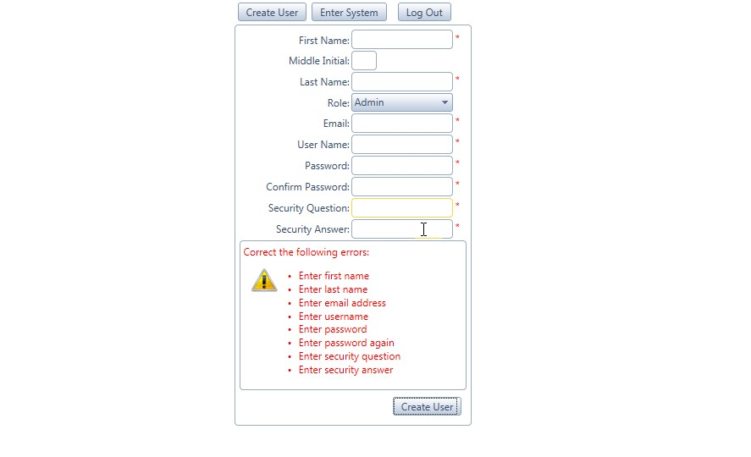

**Screenshot: Trying to submit without proper email formatting**

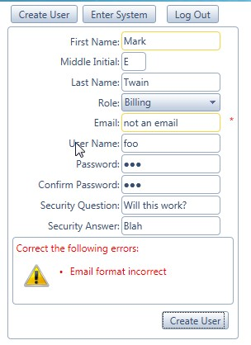

**Update client information in client search**

* Makes sure phone number is 10 digits long without characters.
* Ensures Zip code is 5 digits with no characters.
* Ensures all values are given and there are no nulls.
* Textboxes only allow the amounts of characters allowed in the database.

**Screenshot: Trying to enter null values in required fields and invalid characters in phone number and zip.**

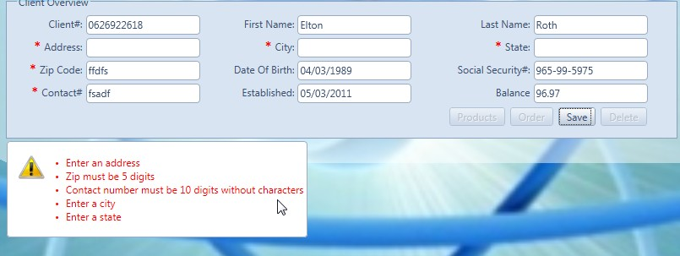

**New client order step 1**

* Makes sure phone number is 10 digits long without characters.
* Zip code validation by web service. (Validate Zip Button)
* Ensures Zip code is 5 digits with no characters.
* Does not allow alpha characters in numeric fields.
* Date of birth has a valid range between 18 years old and 100 years old.
* Ensures all values are given and there are no nulls.
* Textboxes only allow the amounts of characters allowed in the database.
* Cannot add referral number unless WasReferred was set to yes. Referral# field defaults to 0 and cannot be edited.

**Screenshot: Trying to enter null values and leave the required number fields too short.**

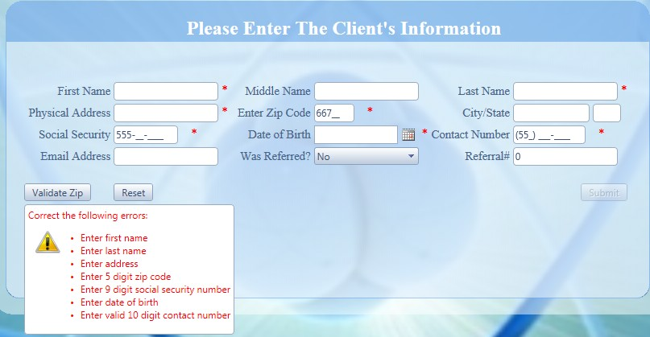

**New client order step 2**

* Validates that a product is selected.
* Validates that no more than 10 products are selected.
* Shows total as products are being selected.
* Shows confirm dialog before moving on to verify products.

**Screenshot: No products selected.**

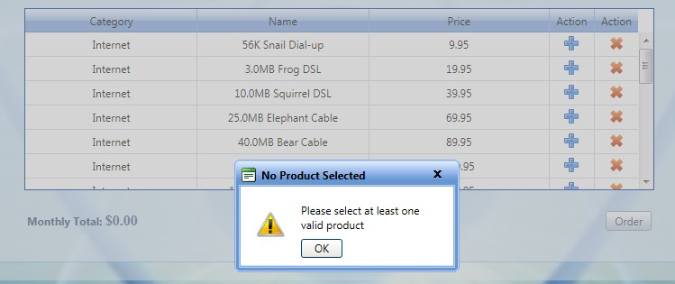

**Screenshot: More than 10 products selected and show total of all selected products.**

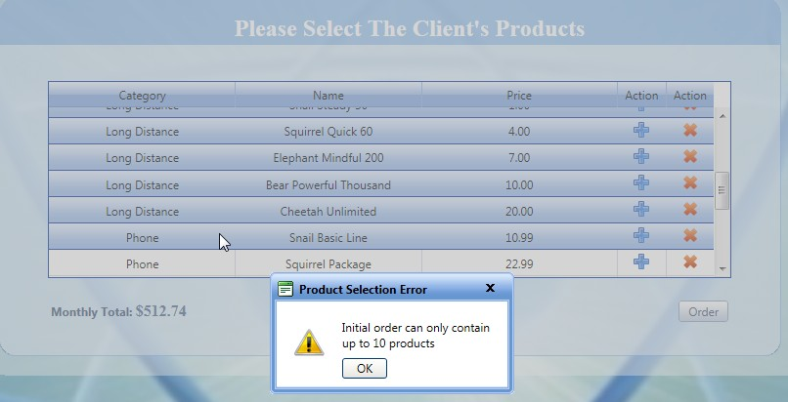

**Screenshot: Confirm totals and products before moving on.**

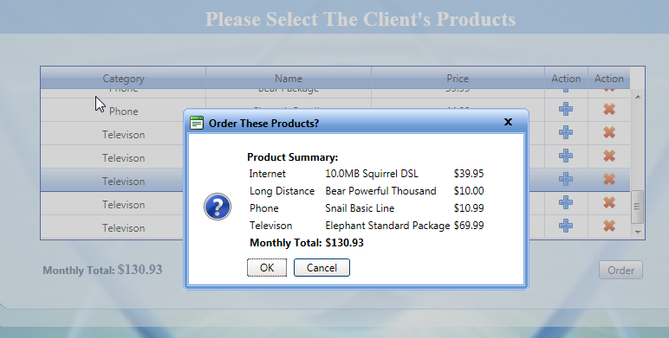

**New Client order step 3**

* Verifies that a due date was selected for the installation.

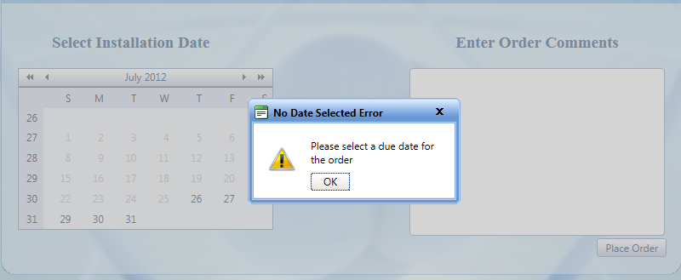

**New Client order step 4**

* Recap to ensure integrity of the data

**Screenshot – Recap Client’s Order**

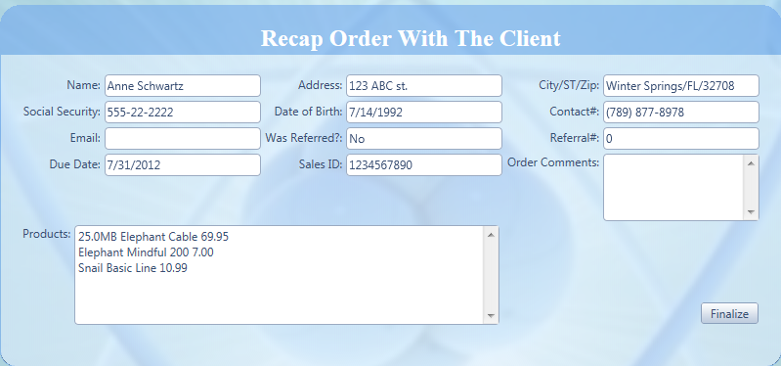

**Order Search – Searching for existing orders**

* Verifies that due date is between today and 3 months out.
* Verifies that if the order is set to “complete” that the due date has to be today’s date.
* Verifies that the date is in the proper format.

**Screenshot – Verify that date is within range.**

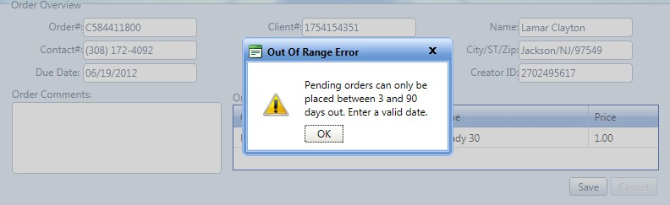

**Screenshot – Verify that date is in proper format with proper characters**

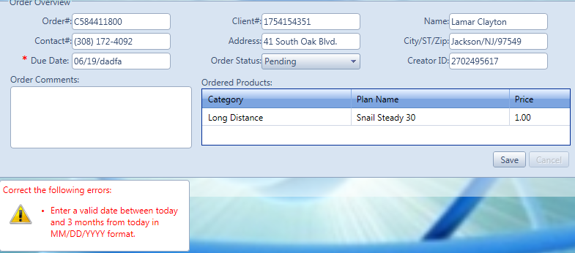

**Screenshot – Verify that date and status make sense. If set to completed, the due date has to be today.**

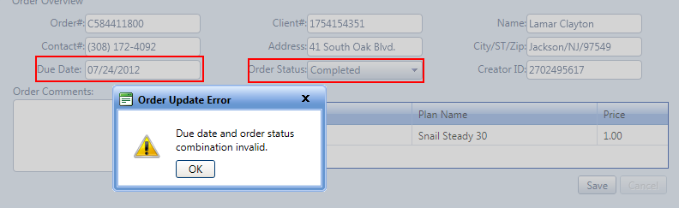

**Order Search – Existing client places another order**

* Verifies that up to 5 products are selected
* Verifies that due date is selected.
* Verifies that at least one product is selected
* Ensures that the existing client does not already have a pending order already in the system.

**Screenshot – Verify that at least one product is selected**

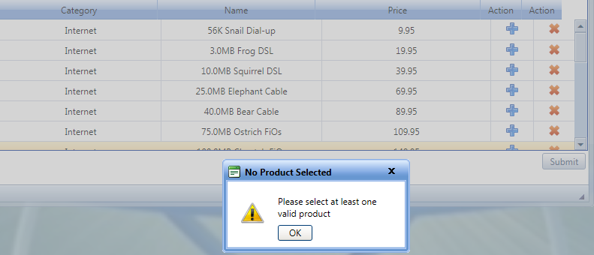

**Screenshot – Verify that at only up to 5 products are selected**

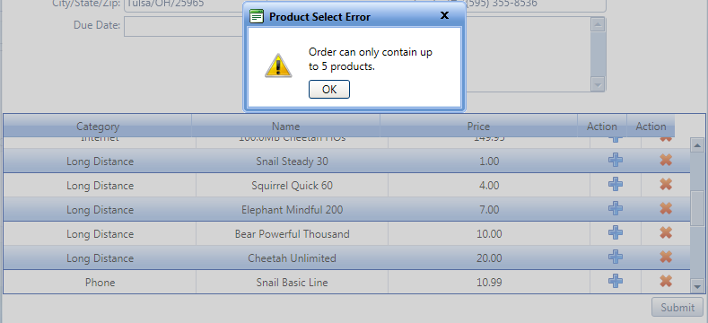

**Screenshot – Verify that a due date is selected**

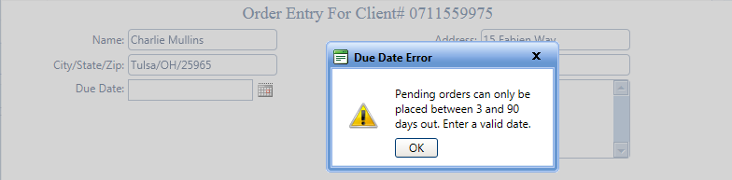

**Screenshot – Verify that the client does not already have a pending order.**

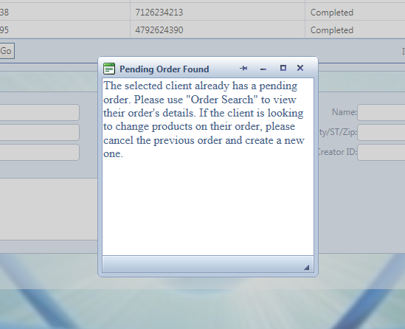

# I.O.N.S User Documentation

## Data Conversion

I.O.N.S does not contain any batch or automated data dumping capabilities so all data will be inputted into I.O.N.S manually. The existing clients in your system will have start dates starting 3 days from the time they are entered into the system. It is my suggestion to put the original date of sale for legacy clients in the order comments of their new order (as they are being input into the system) so the record is kept. Check the New Order section of the documentation on now to enter a client into the system. This should be done by an administrator since only administrators and salespeople have the ability to enter new orders. The data conversion process should take roughly 8 weeks to have all data in the system and verified. Salespeople should not enter the orders because they may be credited for the entry of an existing client rather than new clients. All of Plumbob’s Existing products are in the system.

## Operating I.O.N.S

### Logging into I.O.N.S

Open up a browser (preferably Google Chrome for the best user experience) and type localhost/IONS/login.aspx in the address bar. Bookmark this page as it is the homepage for the I.O.N.S application. You will have been supplied a username and password by an administrator. Enter your credentials at the login screen.

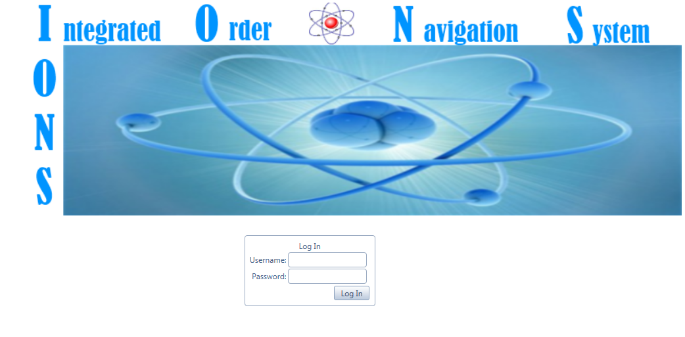

If the supplied credentials are valid, you will be logged into the system. What you see next will be based on your role. If you are an administrator, you will be transferred to the administration page. Any other roles will be transferred to the client search page.

**Administrators:**

You will be transferred to the I.O.N.S administration page.



To create a new user, click the create user button and fill out the required fields. Click the enter system button to enter the system.

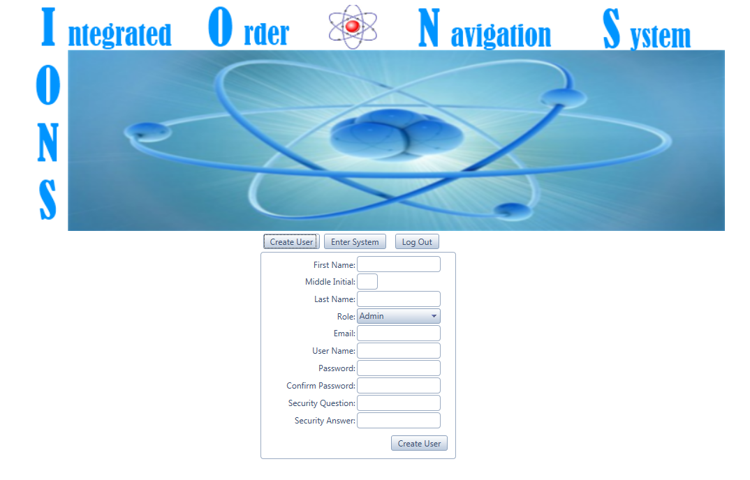

### Inside of I.O.N.S

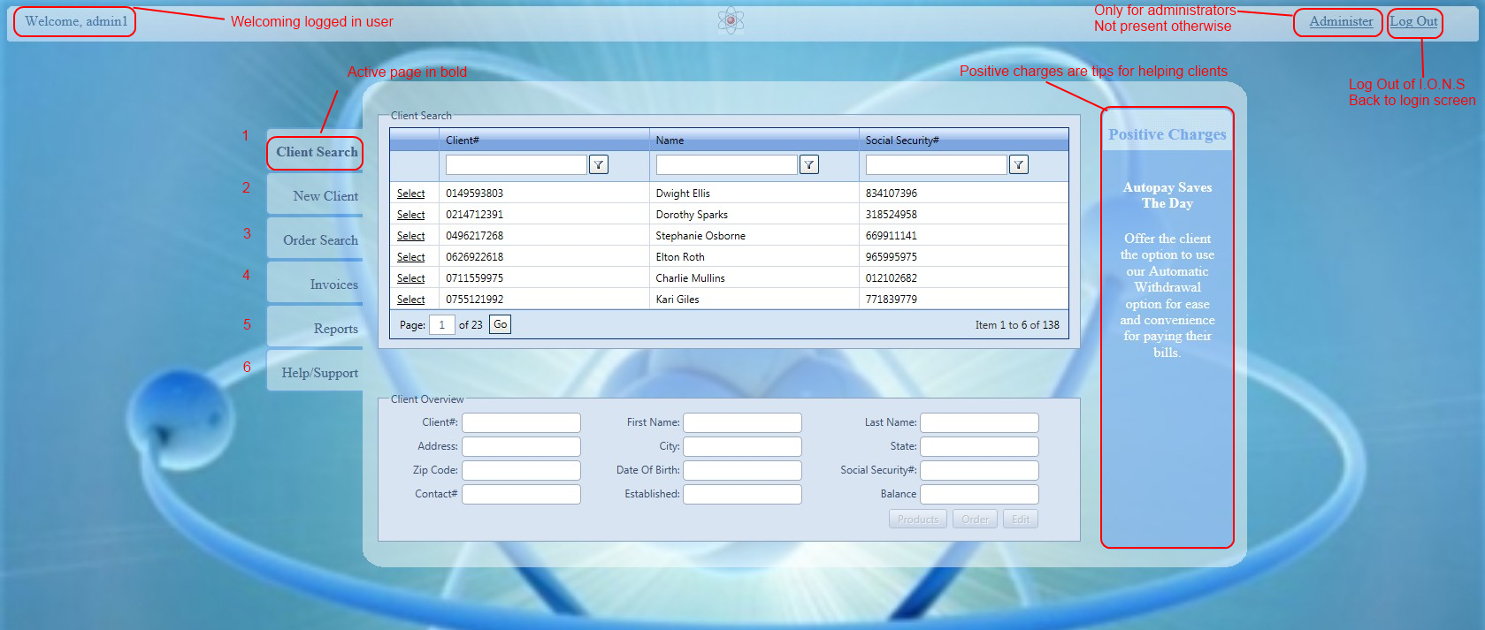

### Section 1: Client Search (Shown above)

In the screenshot below are how to view and change client information. Each button is enabled based on role. The enabled roles are in parenthesis.

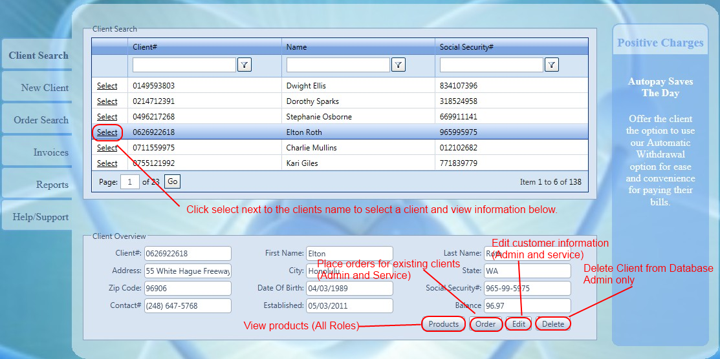

**View Products:**

After selecting a client, click the products button to see the products that are on the client’s account. This does not include any products that are on pending orders.

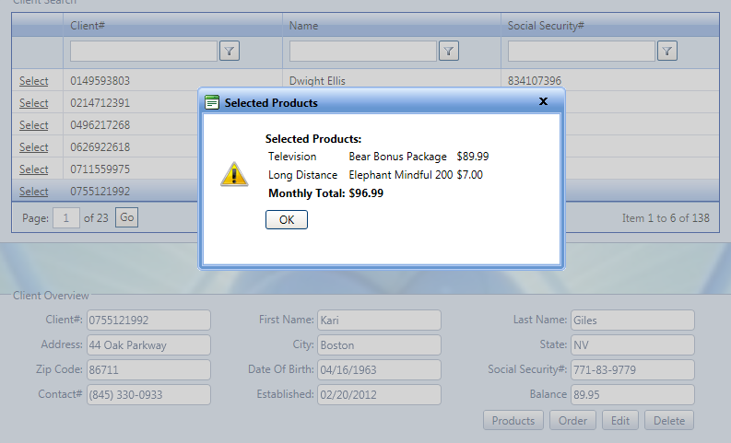

**Place Order:**

After selecting a client, click the order button to place an order for the current client. The user is then transferred to the order search page where the window for placing an order comes up. If the client already has an existing pending order, there will be a popup saying so and the user can look up the order.

*Client without pending order:*

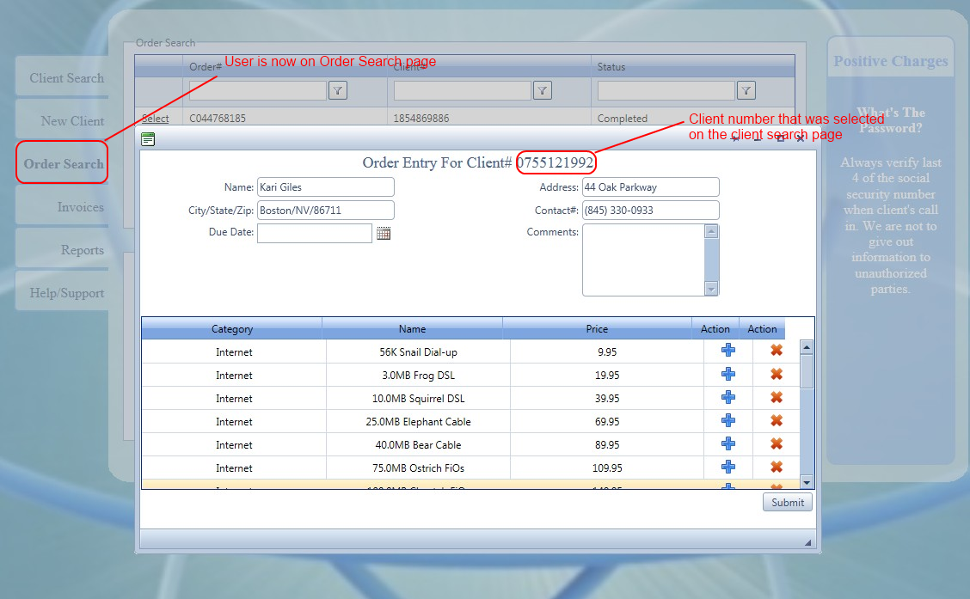

*Client with pending order:*

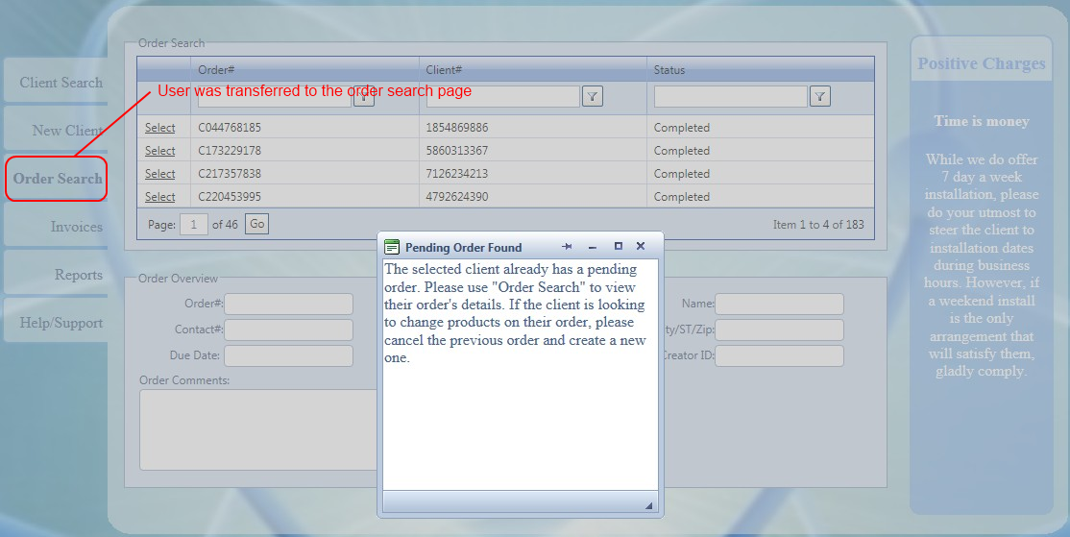

**Edit Client:**

Click the edit button to change the client’s information. The fields that can be changed will be emptied and the save button will appear. If a new client is selected while in edit mode, the new client will be pulled and you will not be in edit mode anymore. **For administrators:** The delete client button will become disabled while in edit mode and will be restored thereafter.

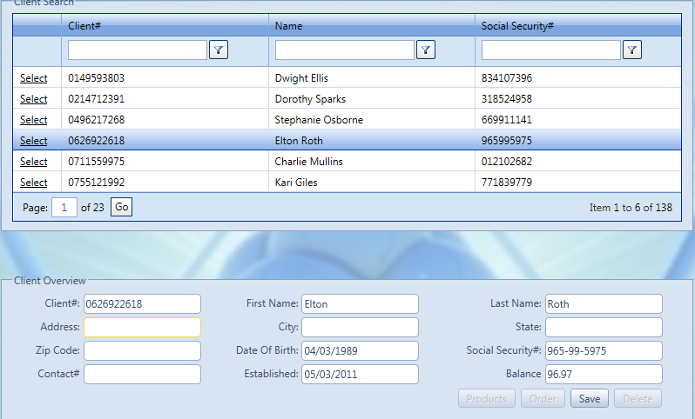

Please verify the information that you are entering in the system before hitting save. There are controls in place but verification is also a good practice.

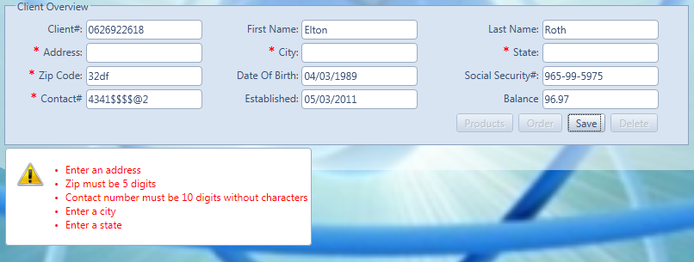

Hit save once you are finished entering the new information. You will get confirmation if the update was successful. If there was an error, a popup will come up. You will also notice that even though the contact number had no characters when you entered it, it will have the proper phone number formatting after you save.

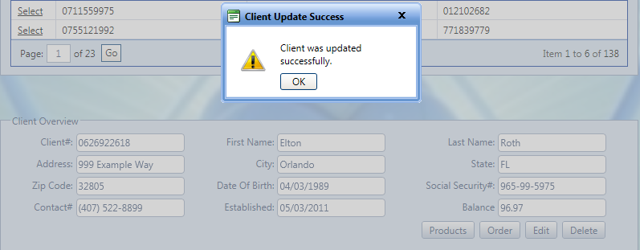

**Delete Client (Administrators):**

After you select the client, click the delete button. After you click the delete button, the delete button will turn black and say “Delete!” If the little black button is pushed, the client will be deleted along with any products on their account, orders, and invoices associated with the client.

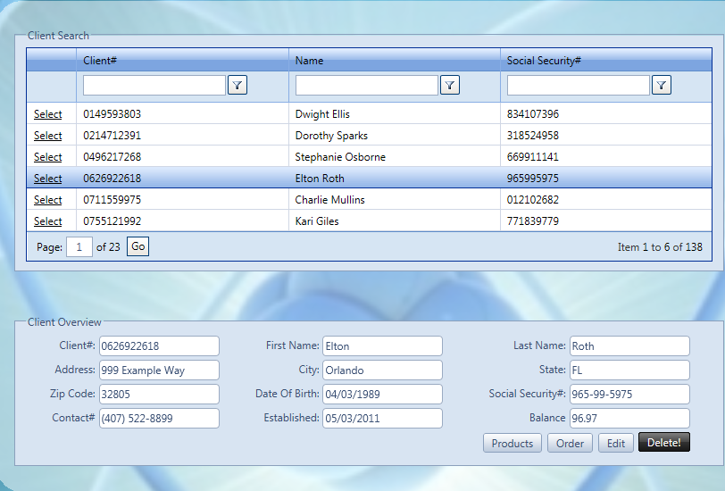

Once the black button is pressed, you will get a popup if it was successful or if there was an error.

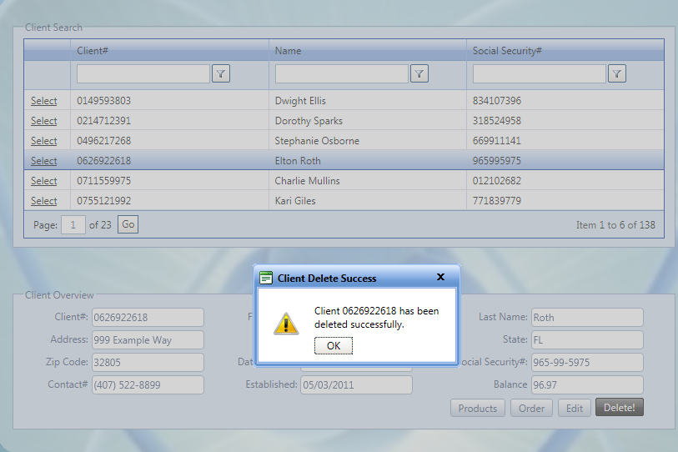

### Section 2: New Client Order Entry (Administrators and Salespeople)

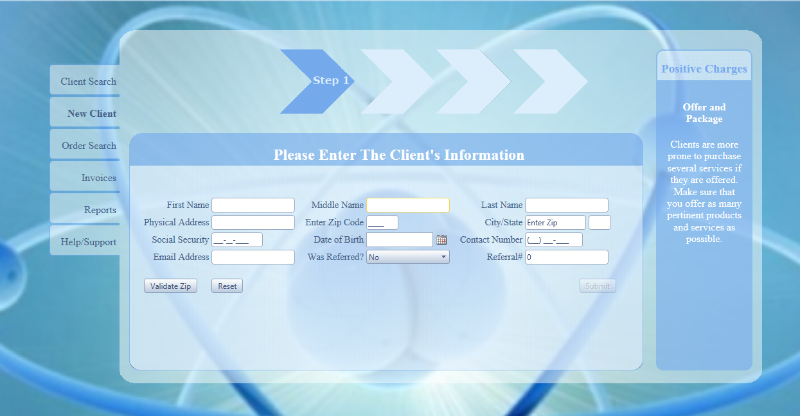

All roles can access this screen but all fields and buttons will be grayed out if the user is not in Sales or Administration.

**Step 1: Client Information**

Enter all data that pertains to the client. The city and state will be pulled when the validate zip button is pressed. If all required information is not give, there will be notification. ***Please verify all information as there is no back button. If something is wrong, you have to start over.***

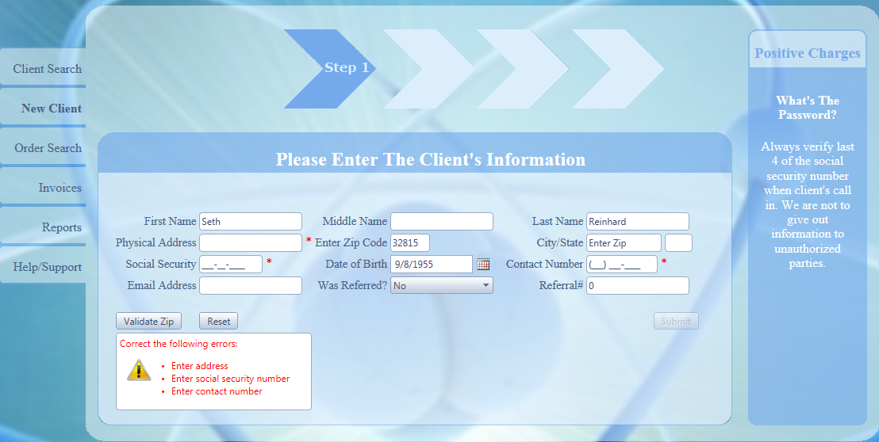

Once all information is entered, hit the validate zip button and the zip code will be validated. If the zip is invalid, a popup will show an error. If the validation service in unavailable, the fields will be enabled for manual input.

*Invalid Zip Code:*

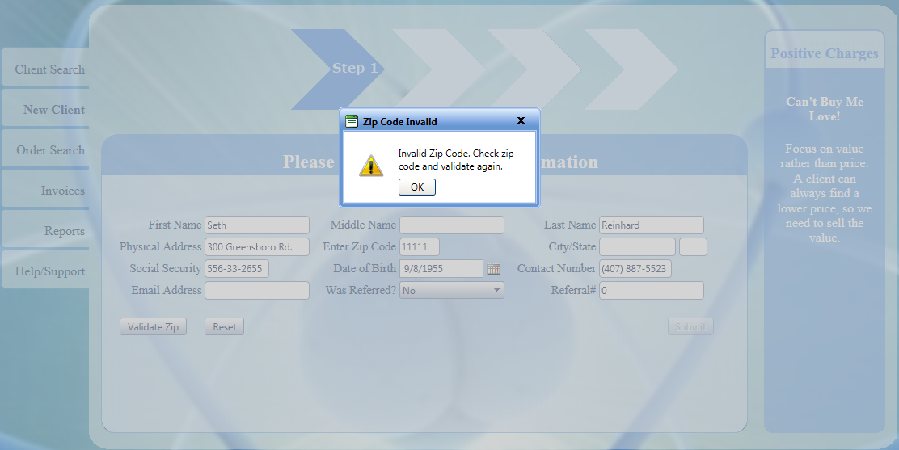

*Validated zip code:*

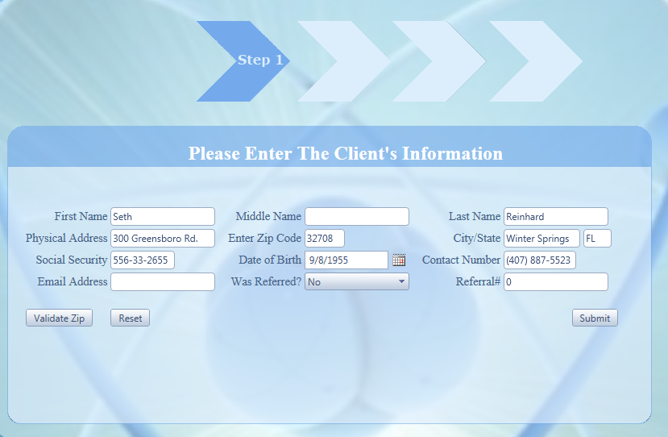

Once the zip code is validated, you can submit the customer’s information. This will check if the social security number is already in the system. If so, there is an error that is given. If you get the error below, use client search to check the social security number.

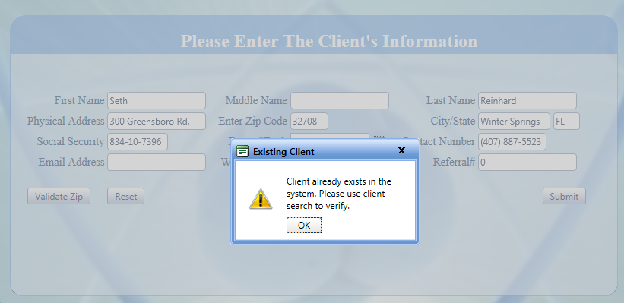

If the social is not in the system, you get message saying the customer verification was successful and to move on to step 2.

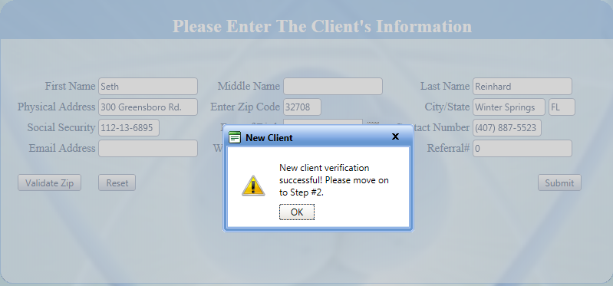

**Step 2: Product Selection**

Use the plus sign to add a product and click the minus sign to remove. You must have at least one product selected and can have a maximum of 10 on a client’s initial order. The total will calculate as you add and remove products from the order. You can scroll down the list to view more. ***There will be a confirmation window that shows the products selected before moving to step 3. Please verify the products as you are able to add any combination of products!***

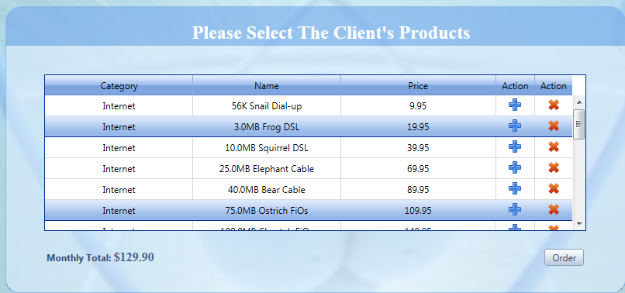

*Order with no products selected:*

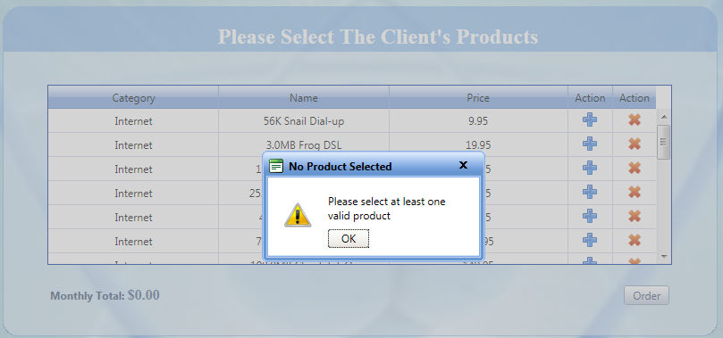

*Order with more than 10 products selected:*

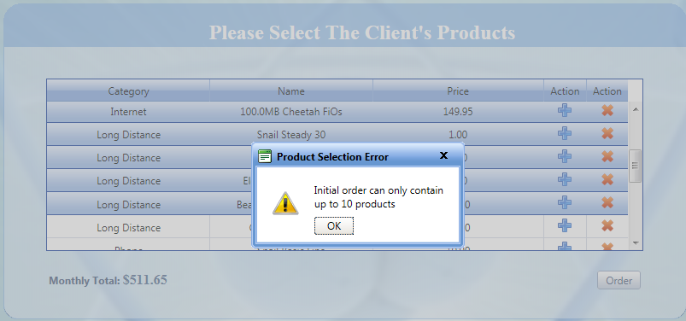

*Verification of products once a valid amount of products are selected:*



Once you click the OK button, you will move on to step 3. Click cancel to revise products.

**Step 3: Order Details**

This section is where you can select the date of installation and add comments to the order. Comments are not required but highly recommended. Comments can include number of computers, televisions, preferred time of day, alternate contact numbers, etc. The installation date selection calendar is already pre-programmed to only show days between 3-90 days out as these are the only windows that Plumbob Communications places orders for. Any date not grayed out on the calendar is valid. Select a date and add comments, then click the place order button. If no date is selected, an error popup shows up. You can submit an order without comments.

*Order with no date selected:*



**Recap order with client:**

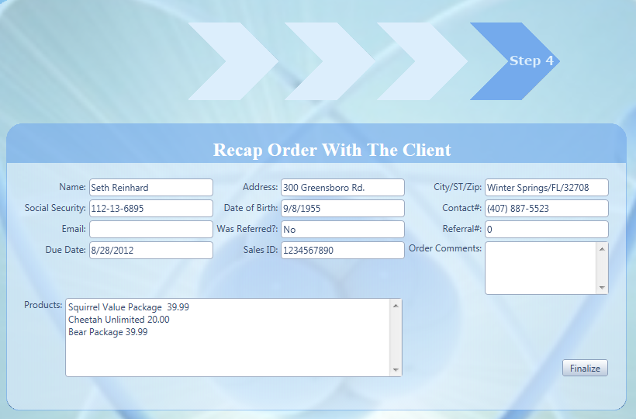

All of the order details will be displayed on the recap screen. Click the finalize button to submit. Then use the client’s social security number in Client Search to look up their client number. You will be transferred to client search upon successful completion of the order. An error will pop if it was unsuccessful.

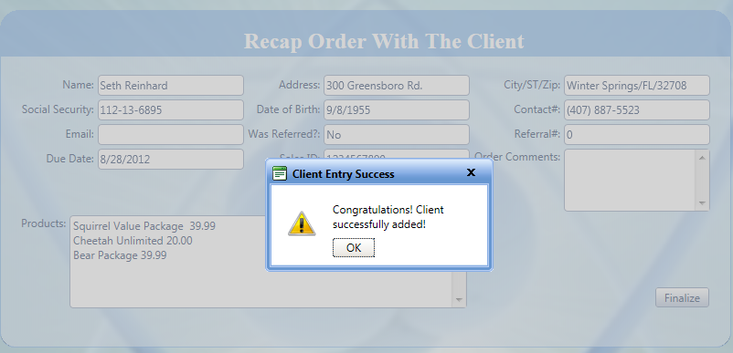

### Section 3: Order Search

**Placing orders for existing clients (Admin and Service):**

This process actually starts on the client search page. Once you click the order button on the client search page you are either met with a message that the client has a pending order in the system or the dialog for placing an order.

*Client with existing pending order:*



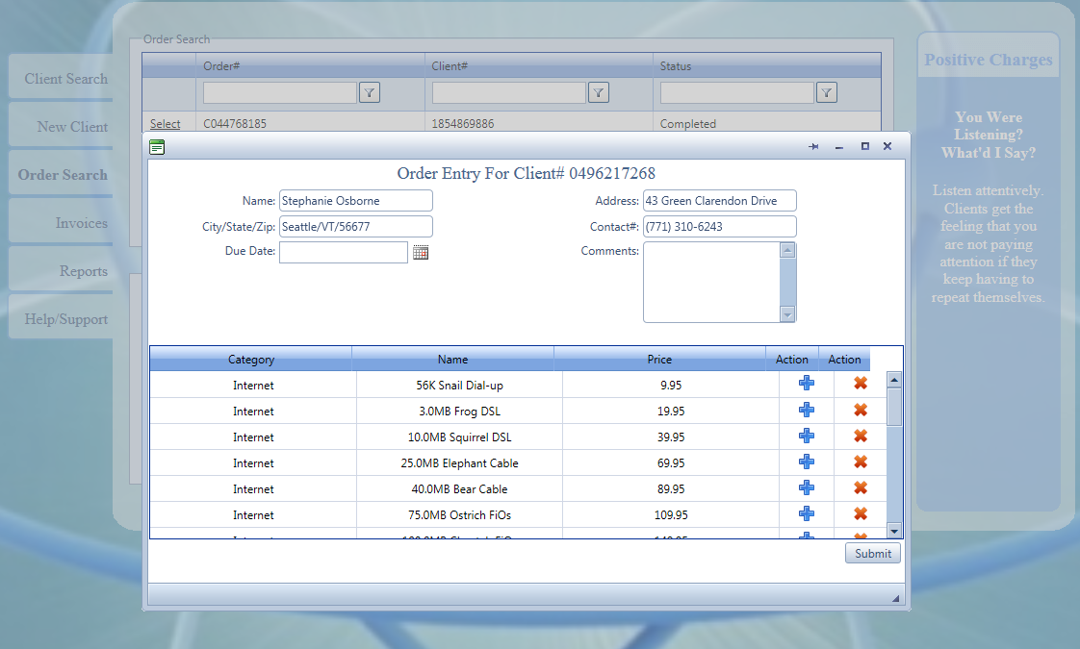

This screen is very similar to the new client’s order screen. Existing clients can only add 5 more products to their account at a time. The client’s information is prepopulated when the screen comes up with the client#, name, address, city/state/zip, and contact#. The due date, comments and products are what can be changed. Add the desired values and click the submit button.

*Client with no valid products selected:*



*Client with more than 5 products selected:*



*Client with invalid/no date selected*

Once a successful order has been placed, the user will get a popup with the confirmation number. Give that to the client for their records. If there is a failure, the user will get an error. ***Common Error: If you add a product that is already on the client’s account to the order, there will be an error. Do not add duplicate services. If you need to verify what the client currently has on their account, use Client Search.***

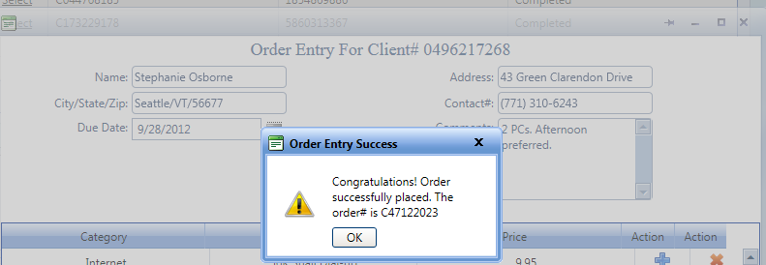

**Edit Orders: (Provisioning, Administrator, and Service)**

Orders that have the status “completed” cannot be updated. You can see the information that was on the order but no edit or pending button is present.

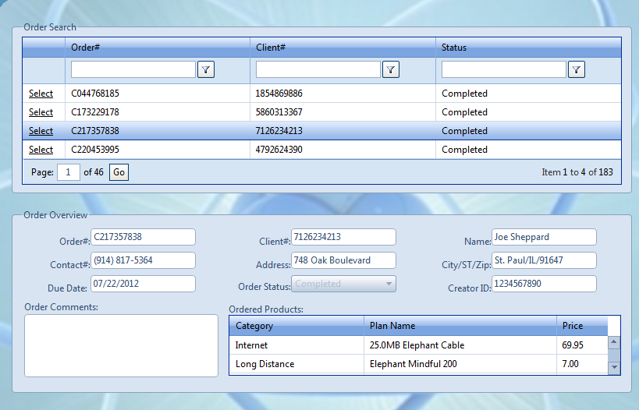

If a pending order is selected, the order will show an edit and cancel button.

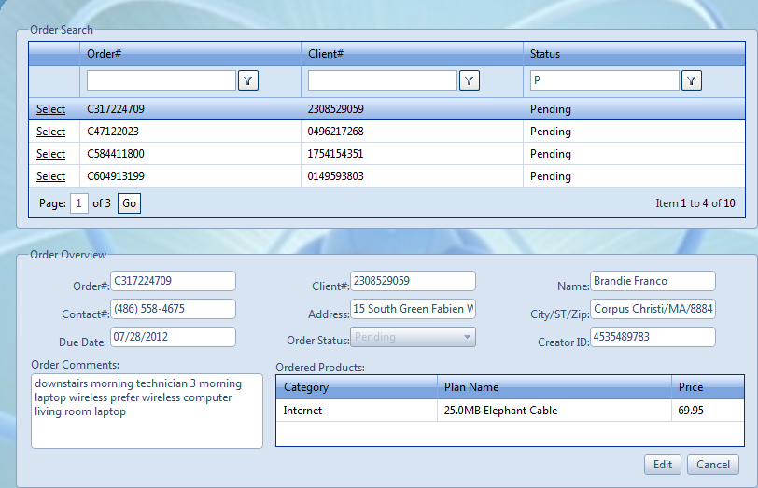

Click the edit button to edit the details of the order. The due date and comments fields will clear allowing them to be edited. Comments are not mandatory but they are recommended. The due date must be between today and 90 days from now.

*Order with invalid due date:*

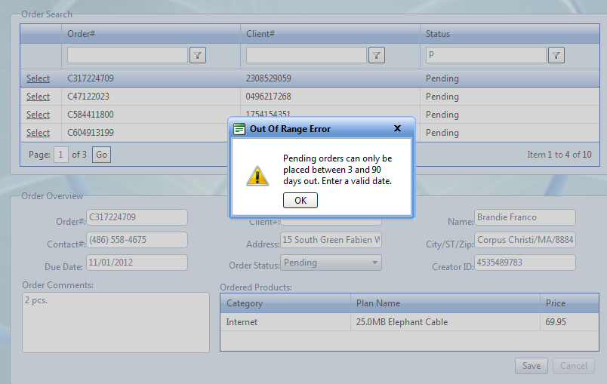

**Administrators and Provisioning:** The order status button will become enabled allowing the order to be completed. **The due date for the order must be set to today’s date to be able to complete the order.**

*Order with due date in the future and completed status selected:*

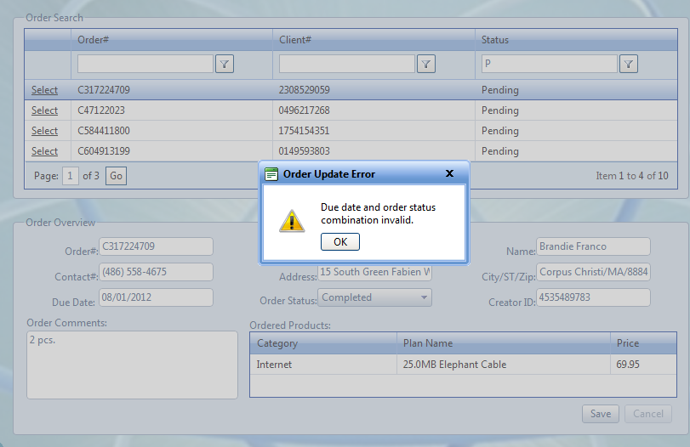

If the order update is successful you will get a message showing that the order is successful.

*Order that was update and is still pending:*

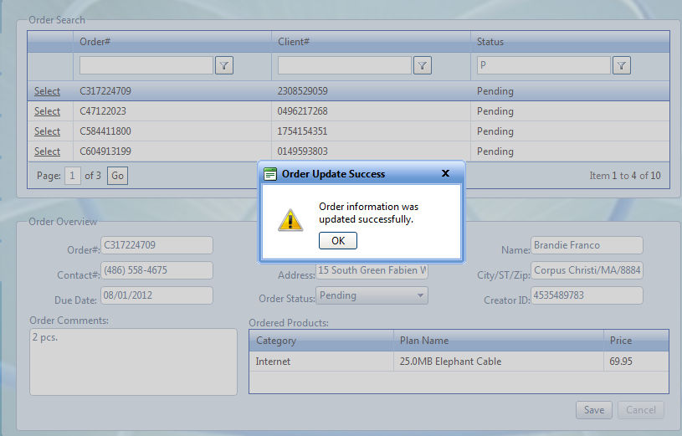

Once the order has been properly completed, the products on the order are added to the client’s account.

*Order that has been properly completed:*

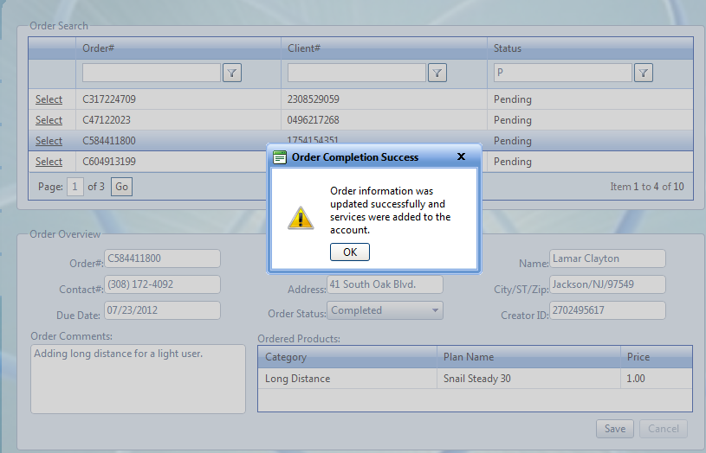

**Using Filters in I.O.N.S to specify search criteria.**

The filters in I.O.N.S on the order search and client search pages are very sophisticated. For 99% of filtering scenarios, the user would use the Contains criteria. To remove the filter, click the No filter option. Play around with the filters to see how they work. The user can always reset all filters to no filter to go to the default setting. **NOTE: *The filters are case sensitive. If the client’s name is Bob and you input “bo“for the contains criteria, it will not pull up the bob you are looking for. You can also look for digits in numbers as well.***

*Searching for a name that contains “Bo”*

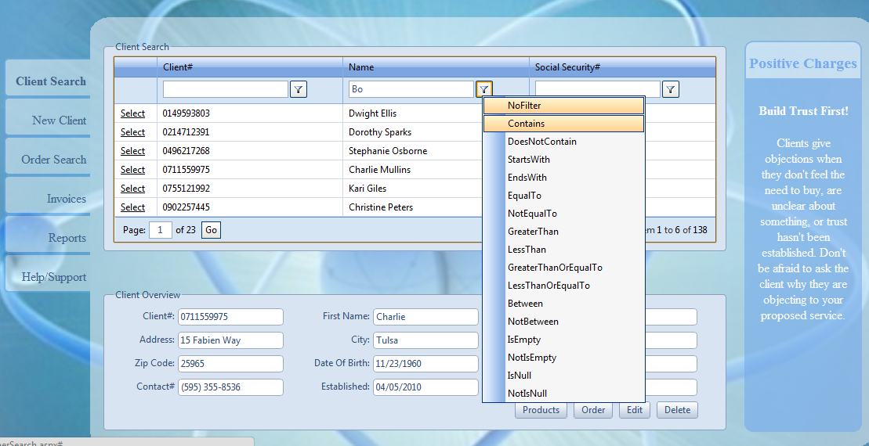

*This criteria yields this result:*

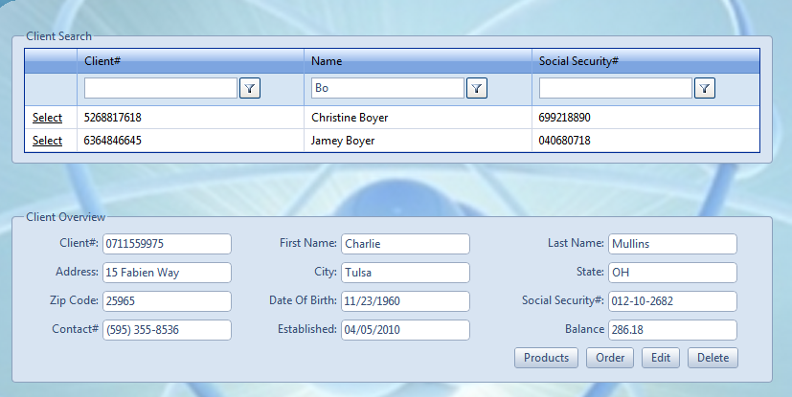

## Section 4: Invoices (All Roles)

**In this section, you can look at a client’s invoices (that are generated by Accounts Receivables). This is where the billing specialists would come to print out the invoices for the clients and mail them out. Service agents can also use this section to go over the bill with clients.**

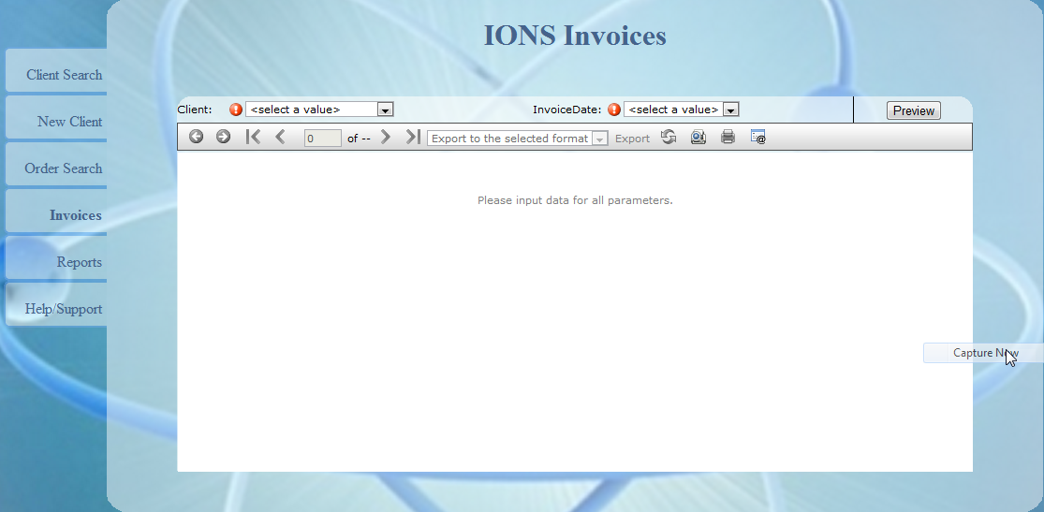

First, select the client. They are ordered by last name.

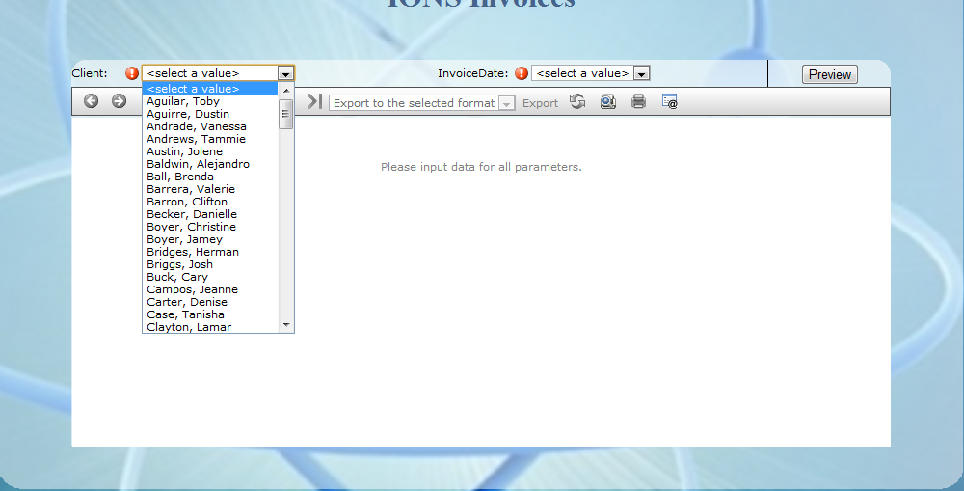

Once a client is selected click the date of the invoice that you want to view.

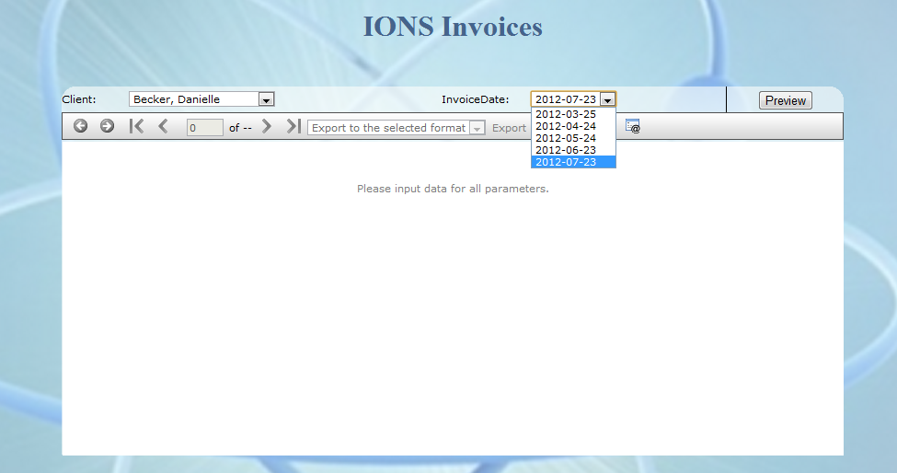

Click the preview button to view the contents of the report. You can export the report into many formats and print them out.

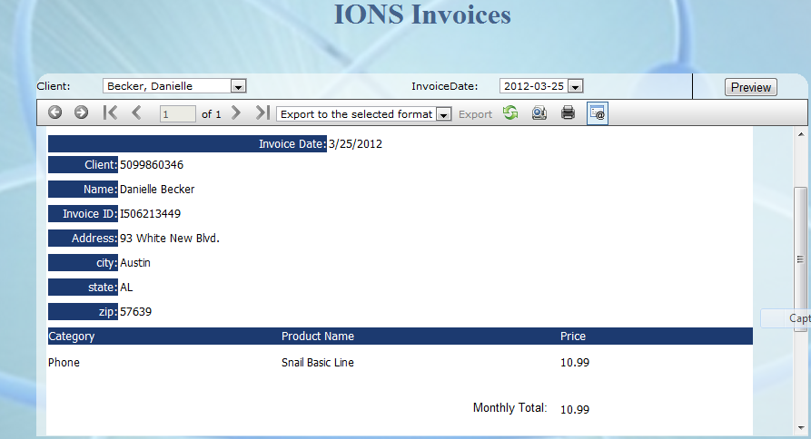

## Section 5: Reports (Report availability based on role)



**Pending Orders Report (All Roles)**

This report shows all orders that are pending and how long they have until their due date. Also shows overdue orders.

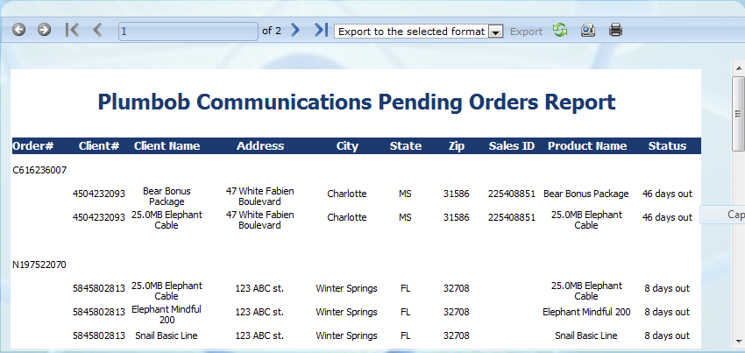

**Referral Report (All Roles)**

The referral report shows all clients that referred a client, the client they referred and the date they referred them. This can be used for marketing campaigns.

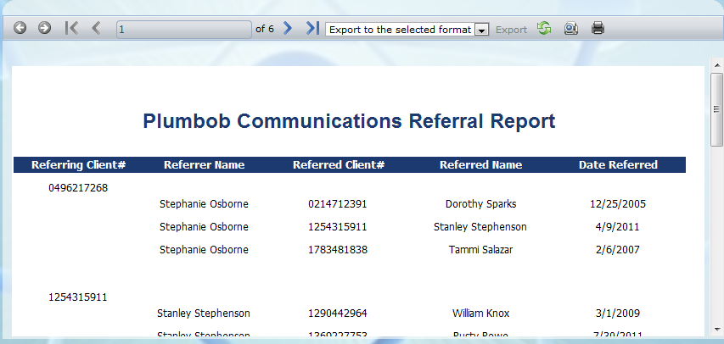

**Sales Report and Sales Chart (Administrators)**

Before inputting the values into the report, this is how it looks. This is normal. The report will format itself once you click preview. Add values for the dates by clicking the calendar or typing the date. Then select a salesperson and click preview.

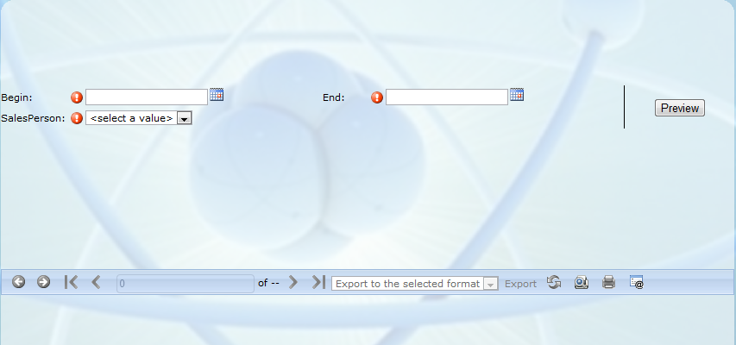

The report will show itself this way. This report contains totals for the salesperson for the specified date, the client they sold the services, etc.

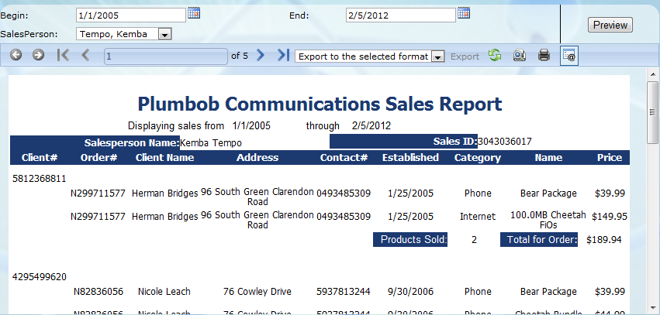

The sales chart is a chart displaying total sales of products for Plumbob on an annual basis. This can be used for projecting and market strategy.

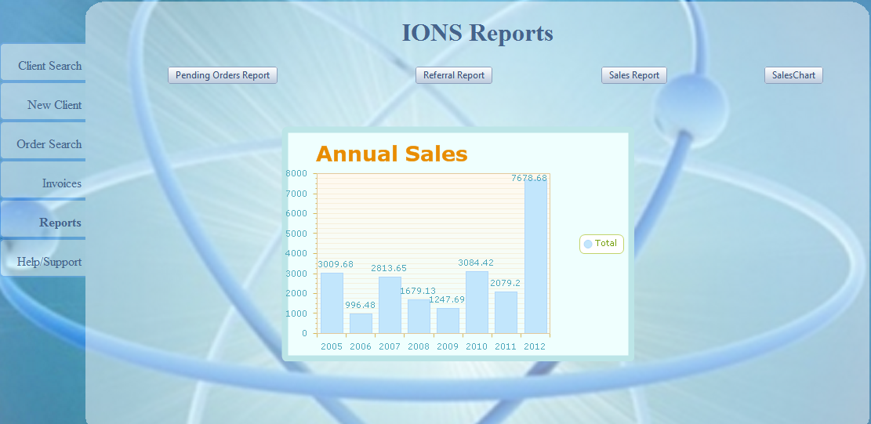

## Section 6: Help and Support (All Roles)

This page contains product information for all users to use. It also has this document for reference.

